
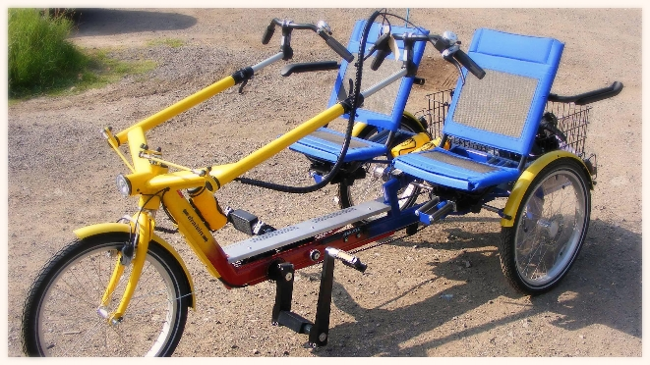

10 more FREE Accessible Cycle Taster Days ☺

at Pedal a Bike Away

Forest of Dean

Gloucestershire

10.30 am – 3.30 pm

Thanks to funding through Gloucestershire County Council from their Active Together grants, Leonard Cheshire Disability, working with Active Gloucestershire, Cycling Projects and Pedal a Bike Away in the Forest of Dean, can offer 10 more free accessible cycle ‘taster’ days for 2015 from 10.30am to 3.30pm on:
Wednesday 28th January
Tuesday 10th February
Tuesday 3rd and Wednesday 25th March
Thursday 16th and Thursday 30th April
Wednesday 6th and Tuesday 19th May
Tuesday 9th and Wednesday 24th June

We'll have a huge selection of adapted cycles – companion trikes (as in the photo above) recumbent bikes, hand cycles, wheelchair platform bikes, and adapted trikes for all abilities from various manufacturers to try out. A mobile hoist will be provided so if you need a hoist transfer please bring your own sling.

THE SESSIONS WILL ALSO GIVE YOU THE OPPORTUNITY TO TRAIN FOR A ‘ROUND GLOUCESTERSHIRE’ VIRTUAL ADAPTED CYCLE RELAY ☺ !!
Please let me know if you're interested so we can plan for numbers or if you have any questions at all: maryclare.faulkner@leonardcheshire.org or phone 01242 512569

Location:
Pedalabikeaway, Cannop Valley, Forest of Dean, Glos GL16 7EH
Phone 01594 860065 or go to www.pedalabikeaway.co.uk for directions
